**A Meta-Analysis of Cover Crop Effect on Weed Biomass and Crop Yield**

Locations:

**Staff Contact:** Sarah Carlson, 515-232-5661, [sarah@practicalfarmers.org](mailto:sarah@practicalfarmers.org), Andrea Basche, __; Alisha Bower, 515-232-5661, alisha@practicalfarmers.org

**Funding**: This project is supported by the Walton Family Foundation and National Wildlife Federation.

**In a Nutshell**

* -
* -
* Key findings
* -
* -

**Background**

Winter cover crops are an important practice to reduce the negative externalities of the dominant cropping system across much of the Cornbelt. This cropping system made up of two crops consists of corn (*Zea mays)* and soybean (*Glycine max)* with active growing roots for only six months of the year. During the fallow period of the year, the winter, soil is predominantly bare. To address significant, negative water quality and soil degradation impacts of this system farmers across the Cornbelt have been growing winter cover crops. Winter cover crops consist of plants sown into standing cash crops or after harvest of cash crops. Cover crops may winterkill in some parts of the Cornbelt while others may overwinter and be present in the spring prior to planting the following cash crop. The practice of cover crops has been around for centuries and is not new but its reintroduction into the Cornbelt has happened only since about 2005. Farmers surveyed in the CTIC/SARE annual survey of cover crops users have reported an increase in the usage of cover crops each year and a total increase in the number of acres they are planting. In addition farmers have noticed significant weed control from cover crops. Some farmers have even conducted on-farm research with groups like Practical Farmers of Iowa and the Conservation Cropping Systems Initiative in Indiana to measure the difference in weed control from a cover crop. Interest in the weed control potential of cover crops is of interest not only to farmers but to ag economists who are interested in the potential cost-savings a cover crop can provide a farmer. Given the extra cost to purchase seed and plant a cover crop finding cost savings can better offset the negative incentive to plant cover crops therefore decreasing a barrier to entry into the practice. If farmers can save in one area of production expenses while incorporating cover crops economic justification tells us that they will be more likely to accept a new practice. However a solid meta-analysis of the published literature about the effect of cover crops on weeds in a corn or soybean cash crop system in the Cornbelt has not been done.

**Materials and Methods**

To better answer the question whether a farmer can achieve enough weed control from a cover crop grown in a corn-soybean or corn-corn system we reviewed the published literature. The studies collected in the meta-analysis were discovered through a combination of reviewing works cited pages and individually reviewing recent years of relevant journals. The criteria by which the authors identified studies to include were as follows:

1. Trials were conducted in states in the broad Upper Mississippi Basin/Upper Midwest area with similar growing conditions, weed pressures, and cropping systems defined for the purposes of this study as Illinois, Indiana, Iowa, Michigan, Minnesota, and Wisconsin.
2. The main cash crop produced in the trial was corn and/or soybeans.
3. Treatments included comparable cover cropped and non-cover cropped trials.
4. Weed density and main crop yield were reported. A majority of included studies also measured cover crop biomass, but it was not a criterion for inclusion.

Published research was initially discovered by first reviewing studies on cover crop effects on weed density already known to the authors. Then, all articles published in 2015, 2016, and the first quarter of 2017 in Agronomy Journal (WI), Weed Technology[1] (IL), Weed Science (IL), Weed Research (U.K.), and Crop Science (NY) were reviewed. These works were coded and all cited literature searched to discover further publications which were coded if they met the criteria for inclusion. For each publication included in the meta-analysis pool, the cited literature was reviewed to discover and affirm that relevant publications were being included in the study.

1. **Research conducted in IL, IN, IA, MI, MN, OH, WI (Upper MS Basin)  
   ii) corn or soybean harvested for grain was the main crop;   
   iii) cover crops were seeded August prior to main crop;   
   iv) weed biomass or density or % control, cover crop species and biomass, and main crop yield was available**.  
   Research years of studies: 1985-2013

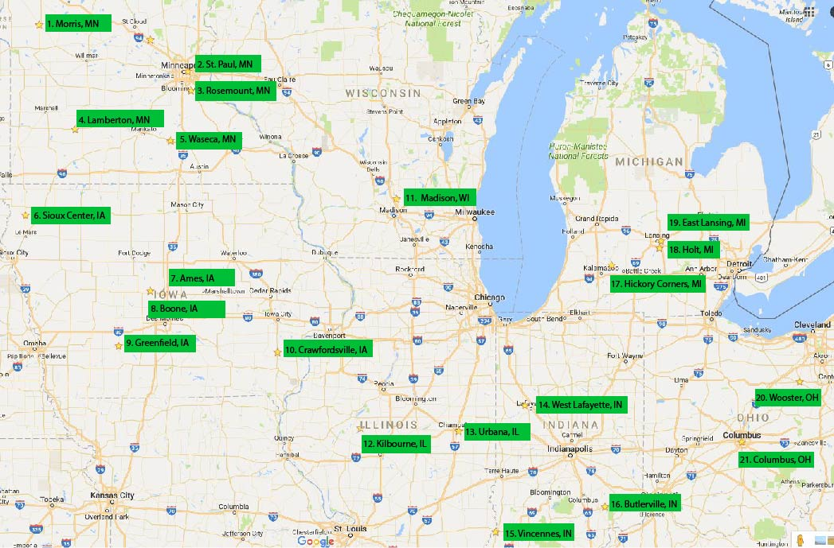

Then, Web of Science search engine was used to find publications that cite each of the articles included in the study.

After all data was scoured from the published literature we calculated a response ratio of the yield of a corn or soybean cash crop with and without a cover crop and the weed biomass measured in treatments with and without cover crops. Response ratios were calculated using the yield of corn or soybean or the weed biomass measured in a cover crop treatment and it was divided by the yield of corn or soybean or the weed biomass measured in a no cover crop check. When multiple treatments were evaluated, as was common, we matched the no cover crop check to all of them. When more than one no cover crop check was tested, as was common when subplots of weedy and weed-free treatments were present, we divided each check against all cover crop treatments to most fairly calculate the response ration of yield of corn or soybean or weed biomass.

Yield Response variable calculated  
**Yield (with cover crop)****÷****Yield (without cover crop)**

Weed Response variable calculated  
**Weed Bio (with cover crop)****÷****Weed Bio (without cover crop**

Response ratios were logged and analyzed using JMP blah blah Moderating Variables Evaluated:

* Cover Crop Aboveground Biomass
* Cover Crop Type
* Cover Crop Planting Date & Termination Date/Method
* % Weed Control

**Results and Discussion**

*Cover crop biomass*

* *CC biomass negatively correlated with weed biomass*
* *Increase CC biomass (2500+ lbs/A) to reach 50% total weed control potential*
* *Greater grass cc biomass could decrease corn yield*
* *Researchers sampled larger cc in soybean studies*
* *Slight soybean yield bump with greater cc biomass*

*Weeds*

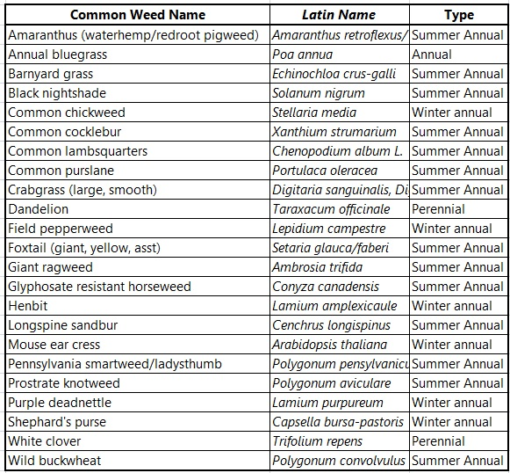

*Corn yield*

*Soybean yield*

**Conclusions and Next Steps**

**References**

PHOTO CAPTIONS

1. At the time that studies were collecting in Jan-Feb of 2017 Weed Technology was the only journal in this pool that had not published the first issue of their 2017 publications. All initial 2017 publications from the other journals were reviewed.